**Student Name:- Chaudhary Hamdan**

**Student Roll No.:- 1905387**

**Algorithm Lab. Class Assignment-4**

**CSE Group 1**

**Date: - 30th July 2021**

1. **Write a C program for bubble sort to**
2. **Compare the time complexity with the given data set given below and calculate the time complexity based on the CPU clock.**
3. **Plot a graph showing the comparison (n, the input data Vs. CPU times)**

|  |  |  |  |  |
| --- | --- | --- | --- | --- |
| **Sl No.** | **Value of n** | **Bobble Sort (Time Complexity)** | | |
| **Best case** | **Average case** | **Worst case** |
| **1** | **5000** | **0.000000** | **0.081000** | **0.071000** |
| **2** | **10000** | **0.000000** | **0.330000** | **0.359000** |
| **3** | **15000** | **0.000000** | **0.807000** | **0.793000** |
| **4** | **20000** | **0.001000** | **1.346000** | **1.616000** |
| **5** | **25000** | **0.000000** | **1.952000** | **2.348000** |
| **6** | **30000** | **0.001000** | **2.778000** | **3.601000** |
| **7** | **35000** | **0.000000** | **4.184000** | **4.841000** |
| **8** | **40000** | **0.000000** | **5.691000** | **6.707000** |
| **9** | **45000** | **0.000000** | **6.954000** | **8.340000** |
| **10** | **50000** | **0.000000** | **8.543000** | **10.418000** |

**Program**

**// Author: Chaudhary Hamdan**

**#include <stdio.h>**

**#include <time.h>**

**#include <stdlib.h>**

**#define sf(x) scanf("%d", &x)**

**#define pf printf**

**#define pfs(x) printf("%d ", x)**

**#define pfn(x) printf("%d\n", x)**

**#define pfc(x) printf("%d, ", x)**

**#define F(i,x,y) for(int i = x; i < y; i++)**

**#define FI(i,x,y,inc) for(int i = x; i < y; i += inc)**

**#define RF(i,x,y) for(int i = x; i >= y; i--)**

**#define pfa(i,a,n) for(int i = 0; i < n-1; i++) printf("%d ",a[i]); printf("%d\n", a[n-1]);**

**void i_o_from_file() {**

**#ifndef ONLINE_JUDGE**

**freopen("C:\\Users\\KIIT\\input", "r", stdin);**

**freopen("C:\\Users\\KIIT\\output", "w", stdout);**

**#endif**

**}**

**void swap(int *x, int *y)**

**{**

**int temp = *x;**

**\*x = *y;**

**\*y = temp;**

**}**

**void bubbleSort(int arr[], int n)**

**{**

**int i, j;**

**for (i = 0; i < n - 1; i++) {**

**int swaps = 0;**

**for (j = 0; j < n - i - 1; j++) {**

**if (arr[j] > arr[j + 1]) {**

**swap(&arr[j], &arr[j + 1]);**

**swaps++;**

**}**

**}**

**if (swaps == 0) {**

**break;**

**}**

**}**

**}**

**int main() {**

**i_o_from_file();**

**/* ********************************************* */**

**pf("n\t\tbest\t\tavg\t\t\tworst\n\n");**

**int sizes;**

**sf(sizes);**

**F(i, 0, sizes) {**

**int n;**

**sf(n);**

**pf("%d\t", n);**

**int arr[n];**

**time_t start, end;**

**double time;**

**// Best**

**F(j, 0, n) {**

**arr[j] = j + 1;**

**}**

**start = clock();**

**bubbleSort(arr, n);**

**end = clock();**

**time = (end - start) * 1.0 / CLOCKS_PER_SEC;**

**pf("%f\t", time);**

**// Avg**

**F(j, 0, n) {**

**arr[j] = n - j;**

**}**

**start = clock();**

**bubbleSort(arr, n);**

**end = clock();**

**time = (end - start) * 1.0 / CLOCKS_PER_SEC;**

**pf("%f\t", time);**

**// Worst**

**F(j, 0, n) {**

**arr[j] = rand() % 10000;**

**}**

**start = clock();**

**bubbleSort(arr, n);**

**end = clock();**

**time = (end - start) * 1.0 / CLOCKS_PER_SEC;**

**pf("%f\n", time);**

**}**

**return 0;**

**}**

**Output**

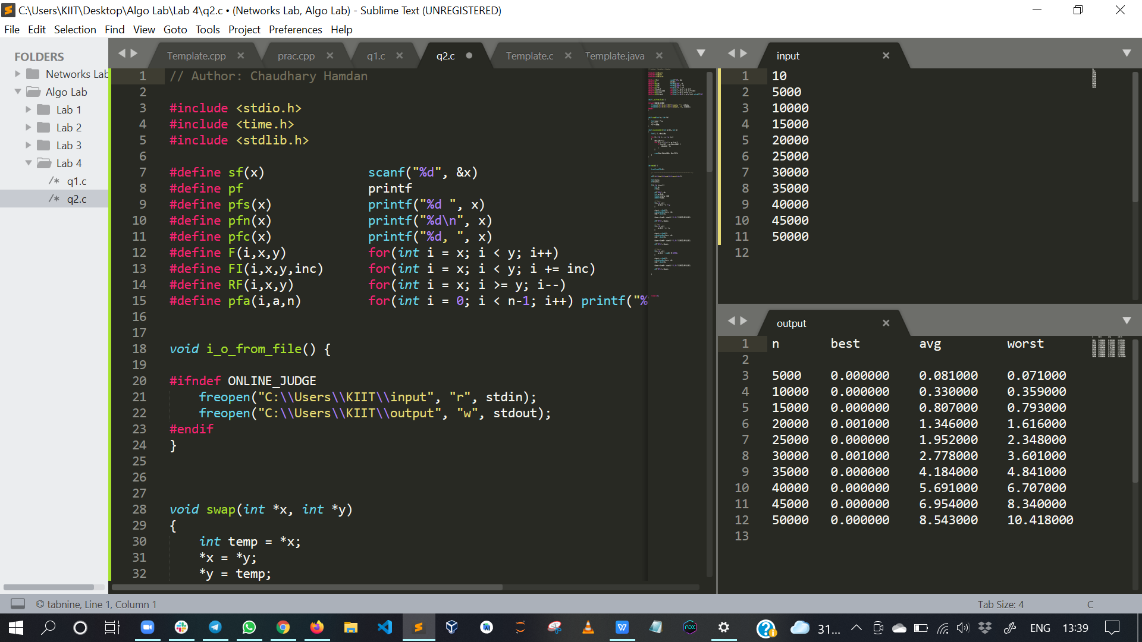

**Graph**

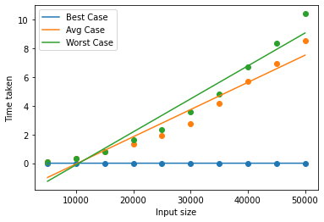

1. **Write a C program for selection sort to**
2. **Compare the time complexity with the given data set given below and calculate the time complexity based on the CPU clock.**
3. **Plot a graph showing the comparison (n, the input data Vs. CPU times)**

|  |  |  |  |  |
| --- | --- | --- | --- | --- |
| **Sl No.** | **Value of n** | **Selection Sort (Time Complexity)** | | |
| **Best case** | **Average case** | **Worst case** |
| **1** | **5000** | **0.040000** | **0.028000** | **0.032000** |
| **2** | **10000** | **0.126000** | **0.130000** | **0.146000** |
| **3** | **15000** | **0.313000** | **0.347000** | **0.330000** |
| **4** | **20000** | **0.552000** | **0.501000** | **0.537000** |
| **5** | **25000** | **0.922000** | **0.919000** | **0.836000** |
| **6** | **30000** | **1.186000** | **1.157000** | **1.248000** |
| **7** | **35000** | **1.706000** | **1.559000** | **1.581000** |
| **8** | **40000** | **2.269000** | **1.991000** | **2.259000** |
| **9** | **45000** | **2.605000** | **2.671000** | **2.654000** |
| **10** | **50000** | **3.411000** | **3.240000** | **3.788000** |

**Program**

**// Author: Chaudhary Hamdan**

**#include <stdio.h>**

**#include <time.h>**

**#include <stdlib.h>**

**#define sf(x) scanf("%d", &x)**

**#define pf printf**

**#define pfs(x) printf("%d ", x)**

**#define pfn(x) printf("%d\n", x)**

**#define pfc(x) printf("%d, ", x)**

**#define F(i,x,y) for(int i = x; i < y; i++)**

**#define FI(i,x,y,inc) for(int i = x; i < y; i += inc)**

**void i_o_from_file() {**

**#ifndef ONLINE_JUDGE**

**freopen("C:\\Users\\KIIT\\input", "r", stdin);**

**freopen("C:\\Users\\KIIT\\output", "w", stdout);**

**#endif**

**}**

**void swap(int *x, int *y)**

**{**

**int temp = *x;**

**\*x = *y;**

**\*y = temp;**

**}**

**void selectionSort(int arr[], int n)**

**{**

**int i, j, min_idx;**

**for (i = 0; i < n - 1; i++)**

**{**

**min_idx = i;**

**for (j = i + 1; j < n; j++) {**

**if (arr[j] < arr[min_idx]) {**

**min_idx = j;**

**}**

**}**

**swap(&arr[min_idx], &arr[i]);**

**}**

**}**

**int main() {**

**i_o_from_file();**

**/* ********************************************* */**

**pf("n\t\tbest\t\tavg\t\t\tworst\n\n");**

**int sizes;**

**sf(sizes);**

**F(i, 0, sizes) {**

**int n;**

**sf(n);**

**pf("%d\t", n);**

**int arr[n];**

**time_t start, end;**

**double time;**

**// Best**

**F(j, 0, n) {**

**arr[j] = j + 1;**

**}**

**start = clock();**

**selectionSort(arr, n);**

**end = clock();**

**time = (end - start) * 1.0 / CLOCKS_PER_SEC;**

**pf("%f\t", time);**

**// Avg**

**F(j, 0, n) {**

**arr[j] = n - j;**

**}**

**start = clock();**

**selectionSort(arr, n);**

**end = clock();**

**time = (end - start) * 1.0 / CLOCKS_PER_SEC;**

**pf("%f\t", time);**

**// Worst**

**F(j, 0, n) {**

**arr[j] = rand() % 10000;**

**}**

**start = clock();**

**selectionSort(arr, n);**

**end = clock();**

**time = (end - start) * 1.0 / CLOCKS_PER_SEC;**

**pf("%f\n", time);**

**}**

**return 0;**

**}**

**Output**

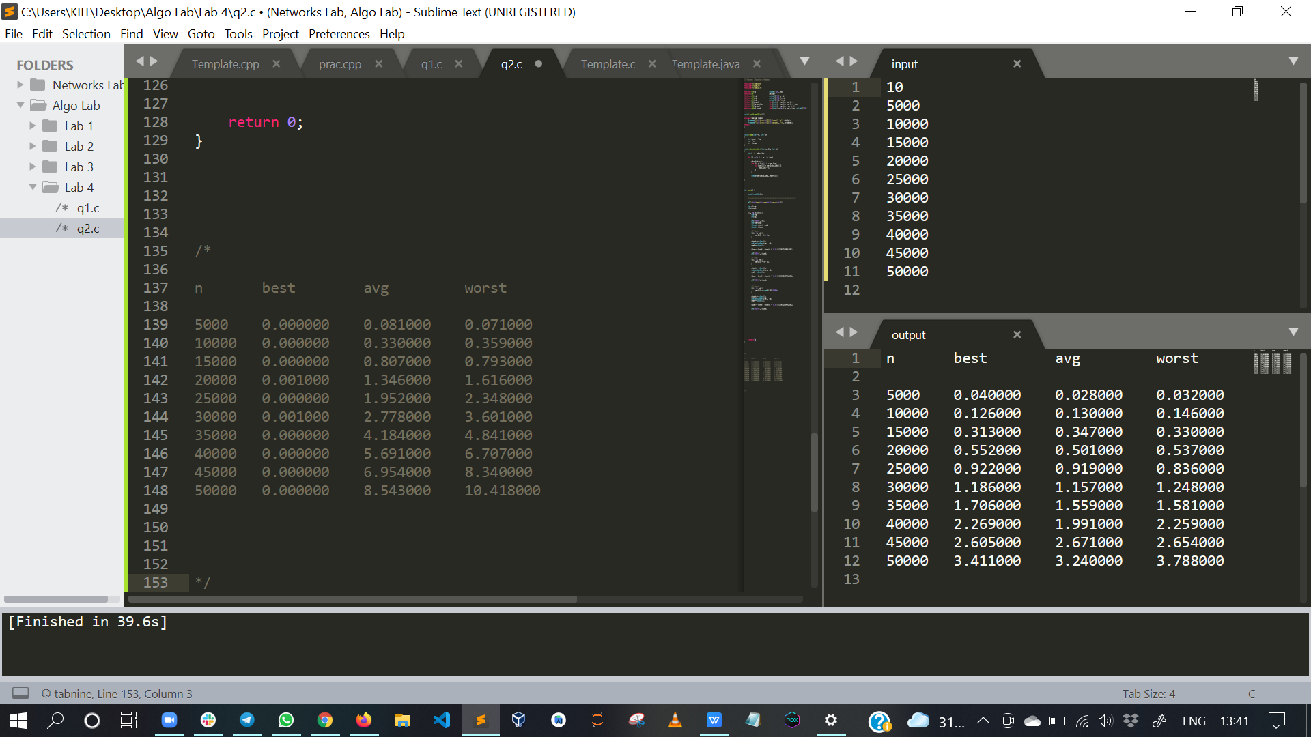

**Graph**

